RKVY : Monitoring Visit to West Bengal
(25-27 February, 2009)
Dr. R. N. Hegde
The monitoring visit to West Bengal began with field visits to districts of West Midnapore and 24 Paraganas South. Soil conservation and Animal husbandry sectors were visited. The NIRD member also called on the Secretary Agriculture, Secretary Animal husbandry and Secretary Fisheries, Government of West Bengal and briefed them about the impressions he gained during the field visits. Discussions were held with farmers, officials and scientists.
General Observations: The RKVY projects started in the rabi 2007-08 with wide range of projects to develop different sub-sectors of Agriculture. The percentage increase of total production of 2007-08 as against 2006-07 was 0.88 and the percentage increase during 2008-09 as against 2007-08 is 5.96 as shown below.

Effect of RKVY on Productivity and Production in the State

Year | Production & Productivity of different Crops in the State of West Bengal
Year | Cereals |  | Pulses |  | Oilseeds |  | Total Production  (Cereals + Pulses +  Oilseeds)  (‘000 MT.)
Year | Productivity  (Kg./ha.) | Production  (‘000 tonnes) | Productivity  (Kg./ha.) | Production  (‘000 tonnes) | Productivity  (Kg./ha.) | Production  (‘000 tonnes) | Total Production  (Cereals + Pulses +  Oilseeds)  (‘000 MT.)
2006-07 | 2575 | 158.20 | 703 | 1.54 | 917 | 6.45 | 166.19
2007-08 | 2578 | 159.03 | 786 | 1.58 | 707 | 7.05 | 167.66
2008-09 | 2649 | 168.30 | 821 | 1.88 | 1005 | 7.47 | 177.65

- Productivity – Kg. /ha.
- Production – ‘000 tonnes.

Sectorwise Financial Progress under RKVY during 2007—08
(Rs.in lakhs)
S.No | Sector | Total fund Outlay | Fund allotted | Total expen diture | % of ach. against approved allocation
1 | Agriculture Deptt. | 2225.42 | 2002.88 | 2114.15 | 95
2 | Animal Resource Development Deptt | 1603.08 | 1442.77 | 1571.01 | 98
3 | Fisheries Deptt | 562.00 | 505.80 | 533.90 | 95
4 | Agril. Marketing Deptt. | 485.60 | 437.04 | 485.60 | 100
5 | Forest Deptt. | 264.25 | 237.82 | 264.25 | 100
6 | FPI & Horticulture Deptt. | 675.79 | 608.21 | 216.25 | 32
Sub Total |  | 5816.15 | 5234.53 | 5185.17 | 89.15
Contingency |  | 120.00 | 103.46 | 69.20 | 57.6
Preparation of C-DAP provided by GOI by separate order |  | 150.00 | 150.00 | 150.00 | 100.00

Sectoral Outlay of funds under RKVY 2008-09
(Rs.in lakhs)
S.No | Sector | Sec  tor  Sha  re % | Allo  Cated Stream - I | Allo  Cated Stream – II | Total | Fund Allotted and Sanctioned (50% of the approved fund) | Funds Utilized as on 31.12.08* | % fund utilized against the approved sanction
1 | Agri. Department | 29.4 | 3338.42 | 996.50 | 4334.93 | 2231.21 | 2817.75 | 65
2 | Animal  Husban  dry  Deptt | 23.1 | 3217.80 | 187.54 | 3405.34 | 1777.68 | 2315.65 | 68
3 | FPI &  Horti  culture | 8.0 | 1155.03 | 28.94 | 1183.97 | 603.56 | 295.07 | 25
4 | Coopa  ration | 7.4 | 1087.48 | - | 1087.48 | 543.74 | 815.61 | 75
5 | Agri.  Market  Ing | 7.4 | 955.00 | 142.00 | 1097.00 | 605.30 | 767.90 | 70
6 | Fisheries | 7.6 | 923.16 | 200.00 | 1123.96 | 642.00 | 842.97 | 75
7 | Water  Reso  urces | 7.1 | 734.29 | 309.19 | 1043.48 | 521.74 | 646.96 | 62
8 | Panch  Ayat & Rural  Devpt | 2.8 | 285.00 | 126.00 | 411.00 | 205.50 | 246.60 | 60
9 | Forest | 3.2 | 192.41 | 285.00 | 477.41 | 238.70 | 380.93 | 79.80
10 | SAU | 0.5 | - | 74.45 | 74.45 | Included under Agriculture |  | -
11 | Agril/  P&RD/SAU | 1.1 | - | 170.00 | 170.00 | 85.00 | Under Progress | -
12 | Fishery/  Minor Irri  gation | 2.4 | - | 350.00 | 350.00 | 175.00 | -do- | -
Total |  | 100 | 11888.60 | 2870.42 | 14759.02 | 7629.43 | 9129.44 | 61.85
* The expenditure incurred by the different sectors are committed
Status of formulation of C-DAP: The process of C-DAP preparation as per the Planning Commission guidelines is under progress. However, the State Government claims that GOI has directly given the responsibility of preparation of C-DAP to organization like MANAGE, PRADAN & NABARD in some districts. The position is furnished below:

Districts | Agency/Position
Jalpaiguri& Siliguri | NABARD
Burdwan | Zilla Parishad
Dakshina Dinajpur, Uttara Dinajpur, Nadia, South-24 Paraganas, Howrah, Coochbehar | AFC
Purab Midnapur | MANAGE
Bankura, Malda, Murshidabad, Hoogly, Birbhum, Purulia, Paschim Midnapur | Not yet engaged Technical Support Institute (TSI)
North 24-Paraganas | Floated Tender for engaging TSI
Darjeeling | Administrative inconvenience to prepare C-DAP.

However, State government hopes that C-DAP will be ready by March 2009 and then it shall be put up to District Planning Committee. But as per the latest report election has been announced and District Planning Committee has been dissolved. Hence, final C-DAP may get ready only after the election. However, my telephone enquiry with NABARD, District Development Manager, Jalapaiguri revealed that he is not aware of any C_DAP preparation by NABARD in his district.
Monitoring arrangements for RKVY:
In order to strengthen RKVY Cell at the state headquarter the nodal department has engaged an administrator. State level senior Officers of the rank of Joint Director of Agriculture/Dy. Director of Agriculture have been entrusted the responsibilities of supervision of RKVY works at the district level as support officers. In addition at the Range Level Joint Director of Agriculture have been entrusted with the job of monitoring and supervision of the districts under their control. The government also constituted a District Level Committee on RKVY under the Chairmanship of Sabhapati of Zilla Parishad with following functions related to RKVY say C-DAP preparation in a time bound manner with due care of convergence of RKVY projects with schemes of NREGS, BRGF, SGSY & Bharat Nirman etc., implementation, monitoring and reviewing of RKVY Schemes in the district, better coordination among the functionaries engaged in the implementation of RKVY Schemes. Meeting of the Committee is expected to be held once in a month. The State Government also proposed to give concurrent evaluation work to NABCONS, Kolkata.

Seed produced and supplied in the State :
Seed Produced & Supplied 2006-07
Sl. No.  Agenda-V | Crop | % of Seed Produced & Supplied by different Sectors during 2006-2007
Sl. No.  Agenda-V | Crop | Govt. Farm | State Seed Corporation | SAU | Other State Agency | NSC | Private
1 | Paddy | 7 | 10 | 1 | 12 | 1 | 69
2 | Maize | 8 | 10 | 5 | 5 | 15 | 57
3 | Wheat | 20 | 35 | 1 | 4 | 35 | 5
4 | Urd | 25 | 30 | 5 | 25 | - | 15
5 | Moong | 20 | 25 | 7 | 6 | - | 42
6 | Arhar | 15 | 20 | 5 | 17 | - | 43
7 | Gram | 7 | 24 | 10 | 16 | 4 | 39
8 | Lentil | 9 | 17 | 4 | 7 | - | 63
9 | Lathyrus | 20 | 20 | 10 | 10 | - | 40
10 | Rape / Mustard | 10 | 30 | 5 | 10 | 2 | 43
11 | Sesame | 15 | 19 | 6 | 8 | - | 52
12 | Ground-nut | 6 | 16 | 2 | 6 | 7 | 63
13 | Jute | 5 | 20 | 3 | 23 | 30 | 19
14 | Potato | 9 | 10 | 14 | 25 | - | 42
Average |  | 12.57 | 20.43 | 5.58 | 12.42 | 6.71 | 42.29

Seed Produced & Supplied 2007-08
Sl. No. | Crop | % of Seed Produced & Supplied by different Sectors during 2007-2008
Sl. No. | Crop | Govt. Farm | State Seed Corporation | SAU | Other State Agency | NSC | Private
1 | Paddy | 9 | 11 | 2 | 13 | 1 | 64
2 | Maize | 9 | 11 | 6 | 5 | 15 | 54
3 | Wheat | 21 | 36 | 1 | 4 | 35 | 3
4 | Urd | 25 | 31 | 6 | 26 | - | 12
5 | Moong | 21 | 25 | 7 | 8 | - | 39
6 | Arhar | 18 | 20 | 6 | 20 | 5 | 31
7 | Gram | 8 | 25 | 10 | 17 | - | 40
8 | Lentil | 9 | 19 | 5 | 8 | - | 59
9 | Lathyrus | 22 | 23 | 12 | 12 | - | 31
10 | Rape / Mustard | 12 | 32 | 6 | 12 | 3 | 35
11 | Sesame | 18 | 20 | 8 | 9 | - | 45
12 | Ground-nut | 7 | 17 | 3 | 7 | 8 | 58
13 | Jute | 5 | 22 | 3 | 23 | 32 | 15
14 | Potato | 9 | 10 | 14 | 28 | - | 39
Average |  | 13.78 | 21.57 | 6.36 | 13.71 | 7.07 | 37.51

Seed Produced & Supplied 2008-09

Sl. No. | Crop | % of Seed Produced & Supplied by different Sectors during 2008-2009
Sl. No. | Crop | Govt. Farm | State Seed Corporation | SAU | Other State Agency | NSC | Private
1 | Paddy | 10 | 11 | 2 | 15 | 2 | 60
2 | Maize | 10 | 11 | 6 | 5 | 12 | 56
3 | Wheat | 22 | 36 | 2 | 4 | 30 | 6
4 | Urd | 26 | 31 | 7 | 25 | - | 11
5 | Moong | 22 | 26 | 7 | 9 | - | 36
6 | Arhar | 20 | 20 | 6 | 22 | 6 | 26
7 | Gram | 10 | 25 | 10 | 18 | - | 37
8 | Lentil | 10 | 20 | 6 | 10 | - | 54
9 | Lathyrus | 23 | 24 | 13 | 13 | - | 27
10 | Rape / Mustard | 15 | 35 | 7 | 15 | 5 | 23
11 | Sesame | 20 | 20 | 9 | 10 | - | 41
12 | Ground-nut | 8 | 18 | 4 | 8 | 10 | 52
13 | Jute | 5 | 22 | 3 | 25 | 33 | 12
14 | Potato | 10 | 10 | 14 | 30 | - | 36
Average |  | 15.07 | 22.78 | 6.86 | 14.93 | 7.00 | 33.36

Convergence: True convergence is expected to reflect in the C-DAP 2009-10 which are new being prepared at the district level as per the Planning Commission. Already District level Committee on RKVY has been constituted. At state Level also high power inter ministerial Committee has been formed for framing policy and implementation of RKVY and its convergence in the State. A committee of Secretaries of Agriculture and allied departments headed by Chief Secretary has been engaged in policy implementation and convergence issues relating to RKVY. However, it is recommended that training to the personnel associated with planning and implementation process at the district level may help to bring convergence of schemes of different departments.
Innovative / Best Practices:
Pranibandhu (Private AI Workers) – A successful model of West Bengal for integrated cattle development. Pranibandhu stands for “Friend of animals”.
Pranibandhu is not only for improving the quality of breeding but also making the scope for self employment. The basic parameters for engagement of Pranibandhu are (i) at least one Pranibandhu in each Gram Panchayat (ii) Number of breedable bovine in the Gram Panchayat. The yardstick is one Pranibandhu for minimum 800 breedable females.
West Bengal is very rich in cattle population. But the main constraint is the low productivity with about 400 litres / lactation. There is no recognized breed of cattle or buffaloes. In the absence of any recognized breeds of cattle or buffalo population West Bengal is lacking behind in respect of milk production. The total bovine population is (Census 2003-04) 18.9 million, out of which 16 million is non-descript indigenous cattle, 2 million are cross breed cattle and 0.9 million are buffaloes. Distribution of the breedable cattle varies from 1300 to 2000 numbers for each Gram Panchayat and as such the idea of Pranibandhu is promoted.
The expansion of Artificial Insemination (A1) network is done to provide doorstep AI service to cover breedable bovine in the state.AI Service is extended to about 5000 centres out of which 1322 are static and 800 are mobile. Paschim Banga Go Sampad Bikash Sanstha (PBGSBS) (estd in 2002) an organization of West Bengal Government acts as a catalyst in the process of improvement of the rural economy by augmenting the productivity level of cattle and buffalo. Breed upgradation is the main objective of this organization to achieve high quality milch cow and buffalo as well as bulls with superior genetic merit. This Sanstha has built a very good infrastructure facilities for achieving its objectives.

AI Infrastructure for cattle development in West Bengal at glance
Name | Number | Name | Number
Frozen Seman Bull Stations | 3
Liquid Nitrogen (LN)Plant | 4 | Bull Mother Farm | 2
LN Storage unit –VIC-6000 | 14 | Pranibandhu units at GP level | 2776
L N Storage Unit-VIC-3000 | 4 | Al Units (Govt) | 2131
L N Storage Unit-VLP-950 | 10 | Training Centres | 6
Quality Control  Molecular Biology Laboratory | 3 | Academy of Animal Resource Management | 1
Embryo Transfer Technology Laboratory | 1

Three Sperm Stations in the state viz. Haringhata (Nadia District), Salboni (Paschim Medinipur district), Beldanga (Murshidabad district) have already been awarded with 15/ISO:2000 certificates and also HACCP-IS 15000: 1998 certificates. All the three stations are highly sophisticated with modern technology approach and can be counted among the excellent stations in the country. The machineries and equipments of these stations are of international standards.
Now under RKVY Scheme, the Semen Sorter Machine is being purchased soon from USA, mainly to sort out male and female sperm from bull semen. The installation of this machine will help to sort the sperm for artificial insemination with only female sperm – semen (FS-straws) and produce rapidly good quality and better yielding cows.
Pranibandhu, the para vets render AI service round the clock unlike government veterinarians, including Sundays and holidays. Some time lady Pranibandhu is escorted by her husband on the motorcycle for AI at odd hours of the day or night. They usually charge a nominal fee of Rs.40/- to Rs.60/- per AI depending on the distance. The added service of Pranibandhu include primary veterinary first Aid, Vaccinations of the livestock and birds against nominal fees. They also participate in fodder demonstration and also help the farmers about marketing of milk, meat and egg. Many of them also act as dealer of EPIC brand cattle and poultry feed of West Bengal Dairy and Poultry Development Corporation. Bank loan oriented dairy scheme with 2 cross bred cows is an additional income under their self employment programme. Initially, Pranibandhu is given cryocans and other accessories along with some medicines and vaccines for primary health Care, Stationeries including 10 numbers of one month old RIR clricks and 10 number of one month old KC ducklings. Some Pranibandhus are availing this facility also based on the space available in their house. They are permitted to render FMD vaccination against Rs.1 per dose. Some selected Pranibandhus are permitted to serve as Livestock Insurance Agents.
Some of the Pranibandhus are given free mobile sets based on their performance with a lifeline BSNL connection and also given incentives of Rs.5 per AI, for those who perform beyond 300 AI per annum. Average monthly income is of Rs.3500/- while some even earn up to Rs.20,000/- and some are taxpayers also. They also receive regular training from Go Samstha. The Sanstha also brought out one album which include the list of top 100 Pranibandhus in the State ,depicting their performance. These 100 come from top 5 Pranibandhus of each district. The album contains details of Pranibandhu like name, address, cell number, work area, villages covered, transport used (motorcycle, bicycle), cattle and buffalo population and breedable livestock in their area, AI done in current year and calves born in subsequent year, average monthly income though AI, total vaccination done and monthly income from primary aid and vaccination etc. Thus Pranibandhu Para vets service is a unique model of West Bengal State for livestock improvement and self employment generation.
Field Visit Observations:
(1) Composite Animal husbandry Farm, Salaboni, Paschim Medinapur district:
Salboni fodder farm measures 302 ha. was established in the year 1969-70 with a view to produce different kinds of fodder seeds for distribution to the livestock farmers of the state.
Farm Section: This farm produces annually about 15 tons of different kinds of forage seeds like maize, jowar, cow pea, oats, napier, stylo etc. About 1500-2000 MT of green fodder and 150 MT of silage is produced. About 120 different cultivars of grasses and legumes are maintained, out of the cultivars 10 grasses and 5 legumes have been proved promising.
Bull Mother Farm: A total of 186 good pedigree mothers are reared to produce bull calves for frozen semen bull station. At present milk yielding 10 Jersey cows, 2 HF cows and 37 Gir cows are maintained.
Frozen Semen Bull Station: Presently the bull strength is 84 which include 32 Gir, 6 Sahiwal, 13 real Sindhi, 2 CBHF (50%), 11 CBJY (50%) and 20 Jersey bulls. Semen processing work is carried out 5 days in a week taking two ejaculations per day. French Mini straw is used for packaging material and a total sperm concentration is maintained as 20 million per dose with a target to reach 8.5 lakh quality frozen Semen Doses in this year (2008-09). Last year the production cost per straw was Rs.6.15 and the net profit was Rs.37,68,170/-.
The activities of the processing laboratory are receiving hygienic semen, processing of semen, physical and micro-scopical examination of semen etc. Frozen semen straws are distributed to the districts.
The projects under RKVY in this farm.
- Establishment of Heifer production Farm: The work pertaining to fencing around the farm and construction of animal sheds (3 nos) to house 100 animals are in progress. 100 animals have already purchased.
- Establishment of Seed Mixing Unit: The land has been identified and marked. Tender have been floated and work will start soon.
- Seed production and distribution to the farmers: 10 per cent of the target has been achieved.
- Modernisation of training institutes: Here teaching aids and renovation of the building work to the tune of 83 per cent has been completed.

(2) Community Rainwater harvesting structures:
This project is being implemented in Garkhali village, Etkhola Gram Panchayat, canning-I block of south 24 paragana district. The soil is inundated during monsoon due to drainage congestion. Lack of irrigation facility and high salinity in soil crops can not be taken in monsoon months. The civil works like rexcavate the existing drainage channel, to drain out excess water and construction of farm ponds to collect rain water during monsoon. The farmers are taking cash crops like vegetables during rabi season. Discussion with the farmers revealed that they are happiy with the project execution and they maintain them on their own, in future.
Action Points:
- Several assets like bunds, drainage, farm ponds, orchards, water harvesting structures are constructed in large numbers under RKVY the sustainability of these assets depends much on the ownership of these by the individuals, community or local Panchayat Raj Institutions. Hence, wherever asset is created stress may be given to mobilize the farmers in the project area to enable them to own them after completion of the work.
- The achievement under RKVY needs to be highlighted by more documentation in the form of publications, success stories for wide dissemination and replication.
- Capacity building of the implementing officers in the block level as well as the farmers in the village in the form of training in maintenance of such assets may be thought of.
- Whenever, development work has been initiated on the farm land, holistic approach to improve the living conditions in these villages by covering the schemes of other departments to have activities like Kitchen garden, Vermi composting, mushroom cultivation and tree planting involving women, school children and landless may be adopted.

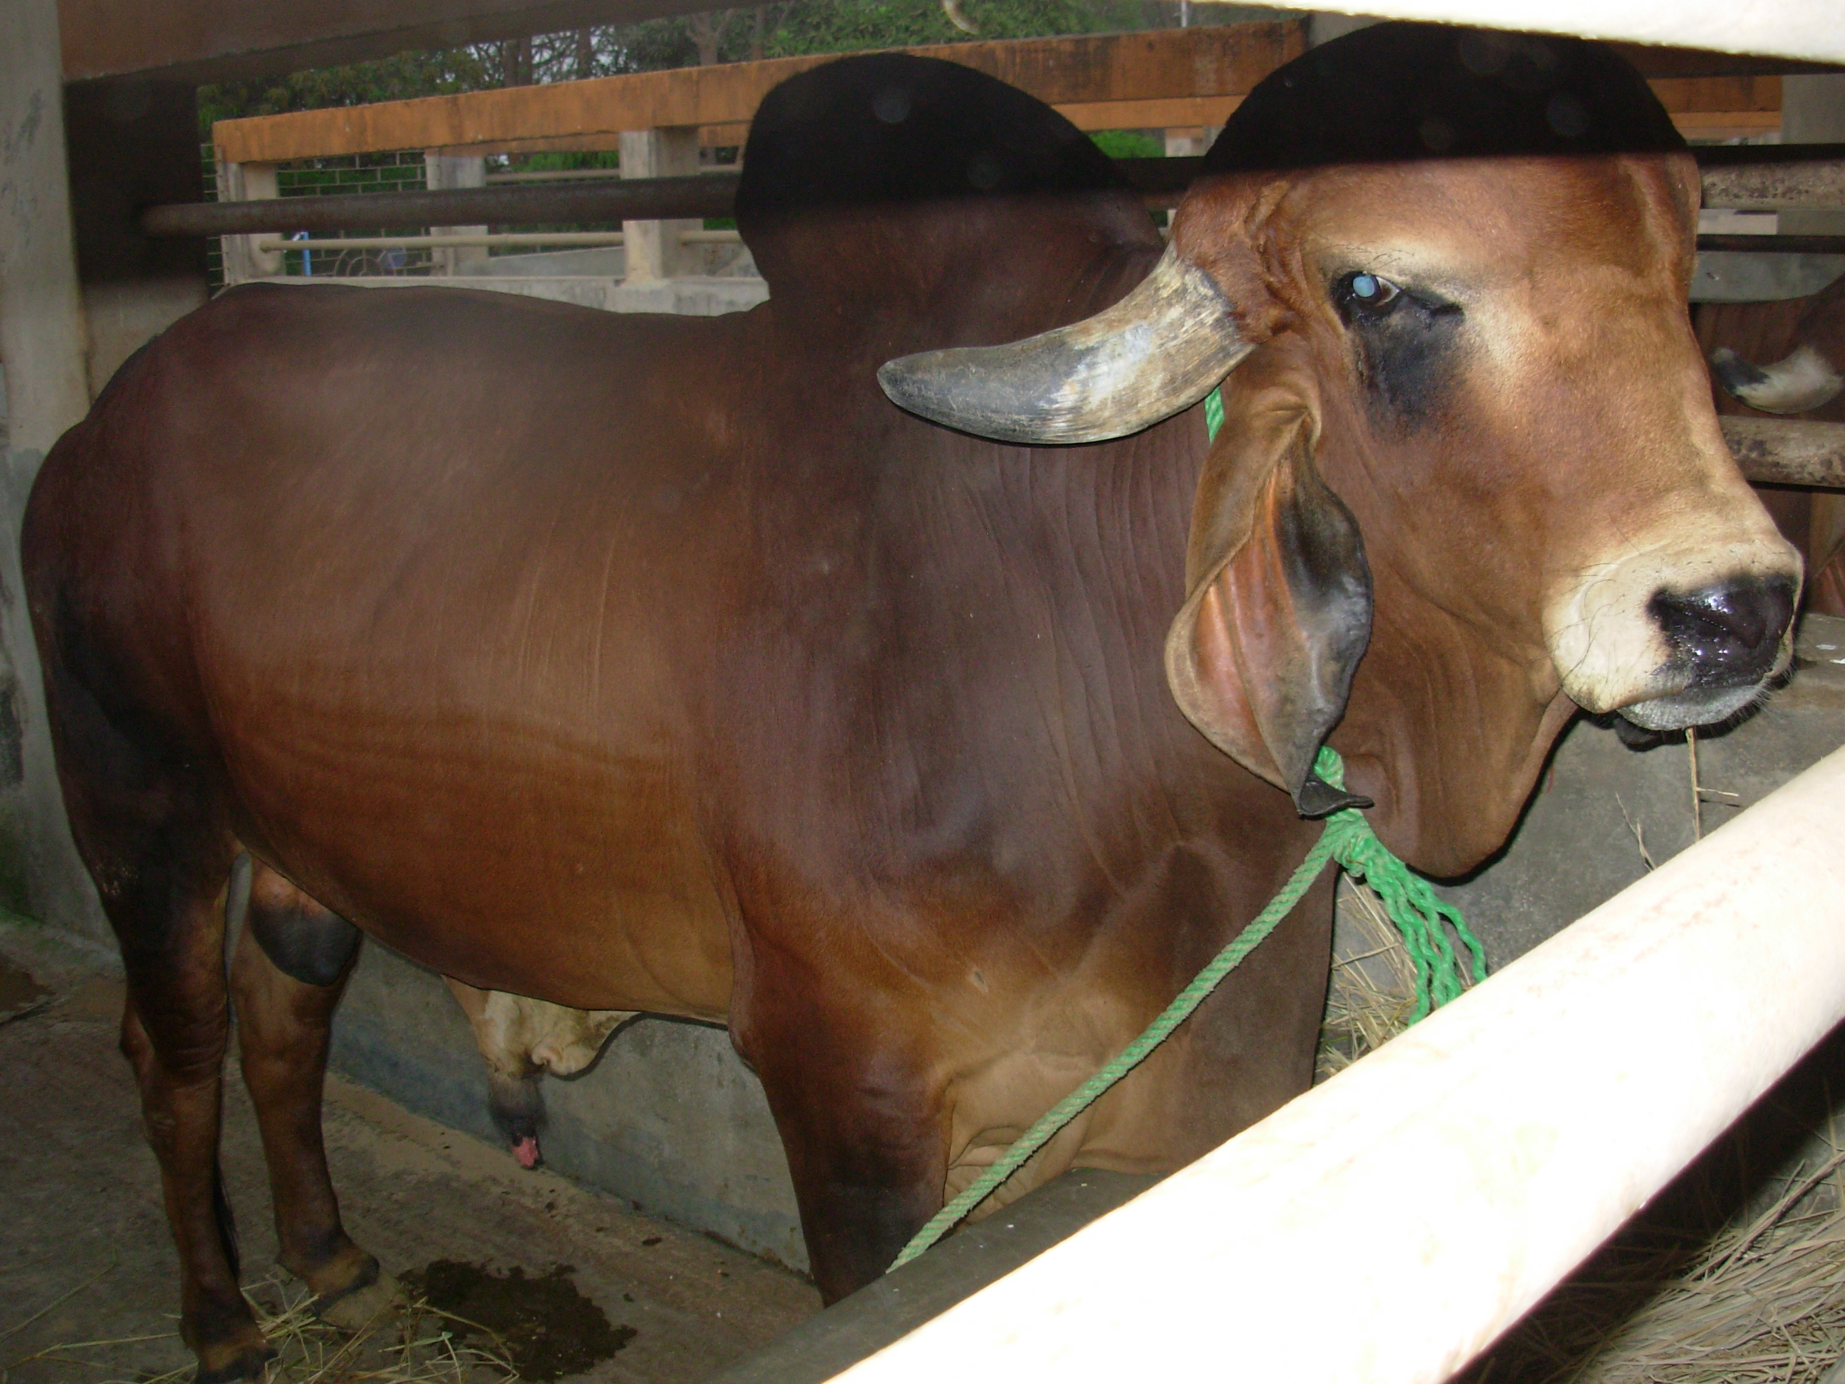
Sahiwal Mother Bull
Liquid Nitrogen Plant
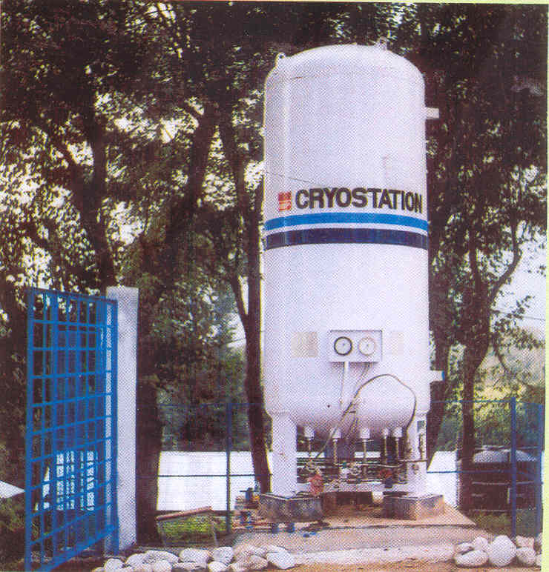

Mobile Pranibandhu (AI Worker)
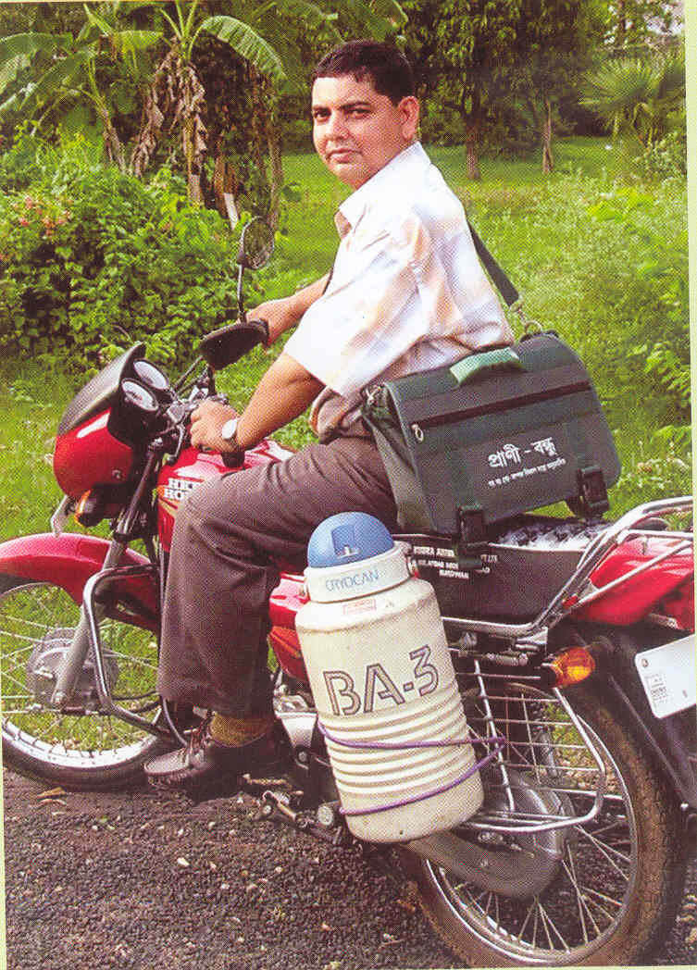

AI Being done by a lady Pranibandhu (Paravet)
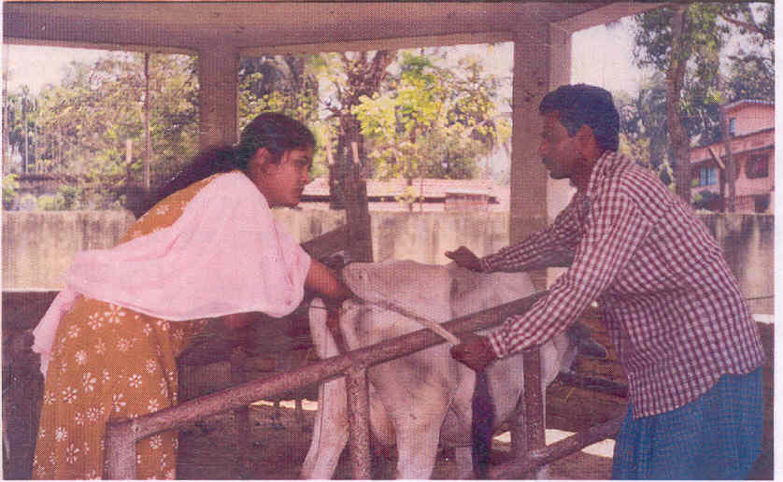

Community Rain Water Harvesting in Saline Soils


