RKVY: Monitoring Visit to Uttar Pradesh

Dr. R.N. Hegde

The monitoring visit to Uttar Pradesh was undertaken on 29th November 2010 to 3rd December 2010. A review meeting was held after the field visits with all the representatives of RKVY Project implementing agencies on 2nd December 2010 at Lucknow. The meeting was chaired by Shri. Sanjay Agarwal, IAS, Principal Secretary, Agriculture, Government of Uttar Pradesh. The progress made by individual agencies with regard to each scheme being implemented by them was discussed. NIRD monitoring Team member expressed that the success achieved by individual agencies should be documented in the form of writing case studies, press releases for wider replication in the state and outside. Field visits were made to the districts of Lucknow, Faizabad, Basti, Sant Kabirnagar, Sitapur, Siddarthnagar and Shahajanpur to know the developments taking place in the villages. Discussions were held with farmers, scientists and field functionaries of the implementing agencies.

General Observations: RKVY started in the state in 2007-08 as 1st SLSC was held on 03.03.2008, however the actual implementation started from 2008-09. The State Government is making good efforts to utilize the funds allocated by Government of India. There are 15 agencies who are implementing nearly 250 projects at present in different sectors. 5 Agriculture Universities at viz., Faizabad, Kanpur, Meerut, Allahabad & Mathura are also implementing nearly 50 agriculture research related projects at a cost of ` 45.00 crore in the areas of seed production, genetic improvement in cattle and buffalo, integrated pest management and integrated disease management, mushroom spawn production, etc. While some research projects have made significant impact, some are yet to make. During the discussion with State Government Officials, it is learnt that the state is considering to get third party evaluation done by agencies like UP Council of Agricultural Research, State Planning Institute & GIRI Institute. In some projects where the agency could not start the Nodal agency proposes to de-sanction and put up to SLSC for allotting the same to some new projects to a different agency.

- Financial Performance: The details of year wise allocations made by DAC, release by DAC, GoI and expenditure made during last 4 years are furnished here below at Table 1. Abstract of SLSC wise details of amount approved and expenditure made under RKVY as on 30.09.2010 is given in Table 2. Year wise expenditure incurred in 2008-09, 2009-10 and proposed during 2010-11 are given in Table 3. Details of SLSC wise projects approved is furnished in Table 4.

- Time lag in fund release at different levels: The statement is furnished in Table 5. It may be observed there was some delay in release from the state Government to the nodal agency during 2008-09 but now it is not taking much time.

- Proportion of projects submitted to SLSC coming from C-DAP: During 2009-10, 81% of the projects were from C-DAP and during 2010-11, 87% of the projects were from C-DAP.

- Proportion of projects from SAP (not shown in C-DAP) submitted to SLSC: During 2009-10, 19% of the projects and during 2010-11, 13% of the projects were submitted to SLSC which were not shown in C-DAP.

- Dedicated team for RKVY at the Nodal Department: A RKVY cell is established at State Head Quarter which is headed by Additional Director of Agriculture (soil conservation) and assisted by a Deputy Director of Agriculture. The cell consists of 5 State consultants, 3 Project Technical Assistants, one accountant, 4 computer Assistants, one Data Entry Operator, one photo machine operator, one IV class who are taken through a service provider. All the necessary work related to submission of the project proposals before SLSC for approval, monitoring and coordination, submission of progress reports are the main functions of the cell. This has enabled the state to generate the required reports and monitor the projects.

- Specific Monitoring visits: The officers of the respective departments pay the visits to the project area during their monthly visits. However, there is a need to further strengthen monitoring in view of coverage of large number of districts in the state. The state has got 72 districts falling in different agro-climatic zones.

- Convergence: The Nodal department has made efforts to have convergence of schemes. However, it is noticed that desired level of convergence has not taken place.

- State Level meetings of all sector departments to review the progress of RKVY: Besides SLSC meetings State Level Meetings under the Chairmanship of Agriculture Production Commission, Principal Secretary Agriculture are conducted on fortnightly basis to review the progress. Monthly meetings are also held at the Directorate of Agriculture to review the projects.

- Innovative Projects: Following projects can be treated as innovative projects for which state Government will be furnishing information which will be forwarded to DAC, MoA soon.

S. No. | Name of the Project | Project cost  (` crore) | Expenditure  (` crore)
1. | Nursery raising of seedlings in polynet low tunnels and production of high value vegetables | 27.13 | 26.93
2. | Reclamation of ravine lands (Katri area) of Ramganga river bank | 50.64 | 45.97
3. | Saghan Mini Dairy Project | 12.01 | 12.01
4. | Adoption and certification of organic Agriculture | 37.34 | 30.23

- District / Region Specific Projects: Some of the projects are stated below:
- Line sowing in selected Eastern districts of UP
- Land reclamation of Katri areas
- Bundelkhand Package
- Extending green revolution to Eastern Region
- Pulses & oil seeds in dry land areas

- NAIP Projects: Extending green revolution to Eastern Region of UP and Promoting Oil seeds and Pulses are some of the NAIP Projects.

- Watershed Development Projects of Rural Development & under MGNREGA: Specific instances are noticed in USDASP projects and Fisheries Department.
- Mechanism for screening project proposals: At present a list of project proposals is prepared by RKVY cell indicating main points / features of the projects which are discussed by the Nodal Officer with the Principal Secretary, Agriculture and the proposals are put up before State Level Implementation and Monitoring Committee (SLIMC) headed by Agriculture Production Commissioner for recommending to SLSC. This system is going on well.
- Online monitoring: Necessary information and progress related to the projects are being fed in MIS. The officers of Department of Agriculture have also attended the training on orientation of RKVY Database and Information Management System (RDIMS) online monitoring at NIRD, Hyderabad. Individual ID number is being given to each project under RKVY.
- Dates of SLSC:
1st SLSC – 03.03.2008
2nd SLSC – 17.10.2008
3rd SLSC – 03.02.2009
4th SLSC – 24.07.2009
5th SLSC – 21.12.2009
6th SLSC – 29.04.2010
7th SLSC – 21.10.2010

Field Visit Observations:

- Lucknow District: Farm mechanization scheme of State Institute of Management of Agriculture (SIMA). Project Cost ` 45.64 lakhs, Expenditure ` 45.64 lakhs. The institute which is one of the oldest training institutes under the Department of Agriculture conducts regular training for in-service agriculture officers, agriculture field assistants and farmers. The grant has been utilized for renovation of building to keep the tractors and also to buy the tractors. 7 tractors with accessories of different makes have been purchased. This is with a view that the farmers who are buying tractor as per their choice for a particular make should get the training in that tractor only about its running and proper maintenance. The institute would like to receive more funds under RKVY as there is a need to renovate still more buildings in the campus.

- Basti District:
  - Nursery raising of seedlings in low tunnel polynet and production of high value vegetables being implemented by Department of Horticulture.

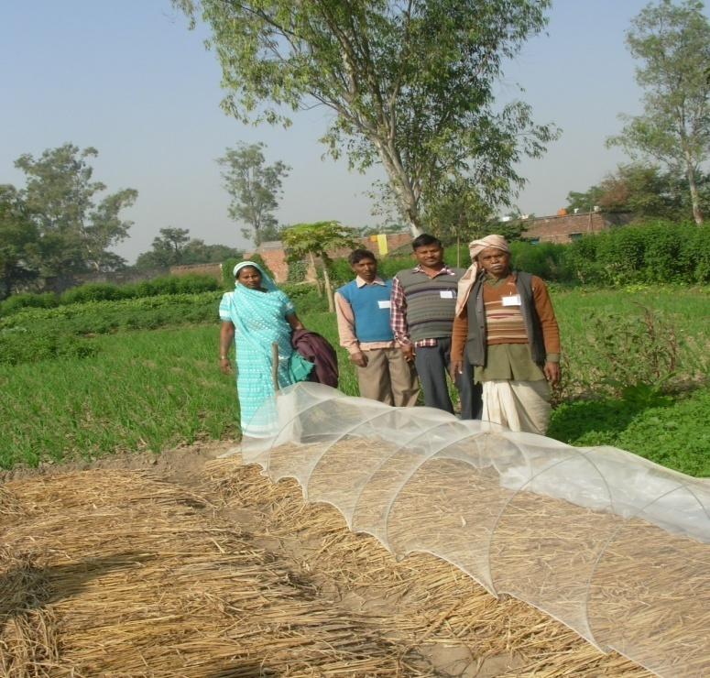
Polynet tunnel for raising vegetable seedlings
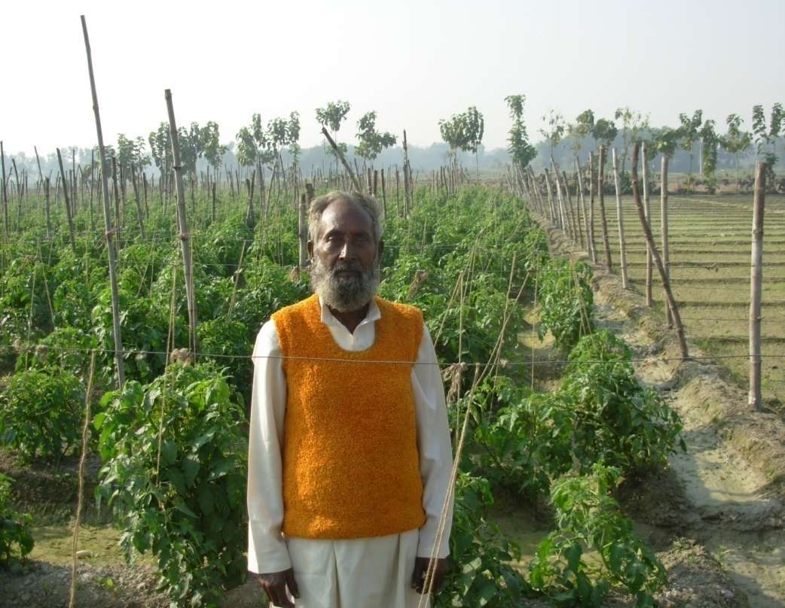
Proud Farmer in staked tomato farm
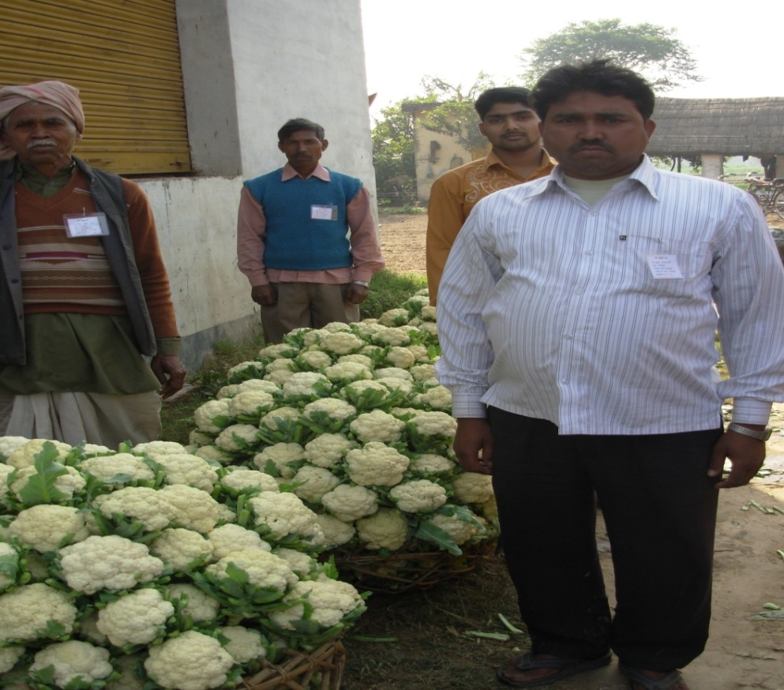
Cauliflower ready for market
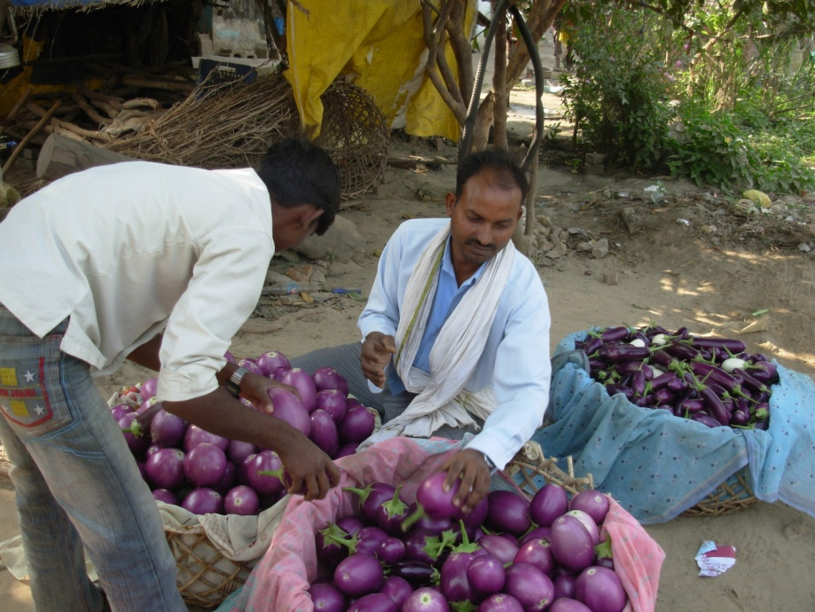
Bumper crop of Brinjal
There are on-going two projects one sanctioned in 2008 with a project cost of ` 27.13 crore and expenditure of ` 26.93 crore and another sanctioned in 2009 with a project cost of ` 33.91crore with an expenditure of ` 1.02 crore.

All the 72 districts of the state are covered under these projects. Major interventions under these projects are

- Raising seedlings by the farmers themselves in the low tunnel polynet (3 feet high) and transplanting in their field with a view to raise disease free planting materials and reduce mortality in the main field.
- Concentration was given to 3 specific crops viz., a) capsicum and chilli, b) tomato and c) gourd vegetables like bottle gourd, bitter gourd, ridge gourd, sponge gourd, cucumber etc.
- Introduction of new hybrid varieties and techniques like staking in tomatoes, raising gourd vegetables on prendals and improving productivity per unit area by adopting better package of practices like Integrated Pest and Disease Management and Integrated Nutrient Management.
- The incentives were given to the small and marginal farmers vegetable growers in the form of 50% of the material cost which included seeds, fertilizers, plant protection chemicals, low tunnel polynet, staking and machan (pendal) etc for good quality vegetable production. The beneficiaries have to bear 50% of material cost and 100% of operational cost (labour cost) required for vegetable production.

Field Visit was made to Pratappur Kalak village of Vikramjot Tahsil and Nagarkhas village of Bahadurpur Tahsil in Basti district where the NIRD team could see successfully grown high vegetables like tomato, chilli and capsicum. These villages have been converted into vegetable villages. The grant amount is ` 17,200/- in kind and ` 4,500/- per acre (0.4 Ha). The cost component is given through cheque for Shimla Mirchi. For hybrid tomato the grant is ` 6,303/- per 0.1 ha. Earlier they used to grow tobacco now the tobacco has been replaced by vegetables. However, the farmers expressed their difficulties in controlling the menace of wild cattle (Blue bull) and wild pigs. Due to the intervention they not only take the vegetables of tomato, chilli and gourd vegetables but also other crops like cauliflower, cabbage, onion and brinjal. It was understood that nearly 150 acres of vegetables are grown in these villages. Even the landless are taking the land on lease and started growing vegetables.

  - Strengthening Government Garden and flower nursery at Horticulture Experiment and Training Centre, Basti being implemented by Department of Horticulture. Project cost ` 10.00 crore, Release: ` 4.41 crore; Expenditure: ` 4.40 crore, out of this ` 50.63 lakhs has been utilized in this centre.

The training centre covers the training needs of both farmers and Horticulture Officers / Assistants for the 13 districts of Eastern Uttar Pradesh. It conducts 4 days and 6 days training programmes. The grant has been utilized for construction of shed, 400 meter length pipeline and digging bore wells and pump-house. Apart from this other investments are connecting roads within this horticulture farm and establishment of medicinal plant demonstration garden.

- Shahajanpur District: Land reclamation of Ravine area (Katri Land) in Ramaganga river banks being implemented by Department of Agriculture:
Sl. No. | Date of sanction | Project release  ` crore | Project expenditure  ` crore
1. | 03.03.2008 | 26.64 | 21.97
2. | 03.02.2009 | 6.00 | 6.00
3. | 03.02.2009 | 18.00 | 18.00
 |  | 50.64 | 45.97

Ramaganga river originates in Pauri Garhwal and enters in Uttar Pradesh in Moradabad and flows through Rampur, Bareilly, Badaun, Shahjahanpur, Farrukhabad and falls in Ganga river in Hardoi. The river keeps on changing its course very frequently, causing heavy erosion and mass sand deposition on fertile lands along its banks. Very often flash flood occur in the catchments of its old paths and water stagnates for 10-15 days causing heavy damage to standing crops. As a result 56,800 ha. of land of 355 villages became barren with very less or no cultivation. Over a period dense shrubs like Moonj, Narkul, Sarpat, Sarkanda, etc covered the land and became a shelter for anti-social elements. The project has got following objectives:
- To bring problematic area in to cultivated land to grow crops.
- To improve socio-economic status of farmers in the project areas.
- To ensure capacity building of farmers through demonstrations.
- To restore law and order in the affected areas.

The development interventions are a) Removal of perennial shrubs and land leveling; b) contour bunding; c) Peripheral bund formation; d) Flood control bunds like check-dam, retaining wall; e) Borewells and pumpsets; f) Construction of link road; g) Crop demonstration of cereals, pulses, horticulture and social forestry.

Field visit was made to Shamshipur Gajipur Pancham village of Barua Panchayat in Madanapur block of Jalalabad Tahashil of Shahajanpur district. The village has a population of around 5,000, the NIRD monitoring team opines that this is the remotest village and most backward village. The village does not have electricity connection yet and village has no facility of Public Health Centre, Bank, Public Transport in the vicinity of 30 kms. To reach the project site Monitoring Team had to travel by car, jeep, boat and then by foot (1 km.). The project site had become almost an island.

The land development has been undertaken using bulldozers and tractors which is done from the contractors of Rajasthan. After reclamation the original land owners have been restored their land and farmers are taking up crops now. 70 ha. of land at a cost of ` 19.426 lakh has been reclaimed in this village. Farmers expressed satisfaction about this project as they could return to farming in their abandoned land. But it will take years to bring these areas into normalcy of development as the area is inaccessible. Lot of improvement in infrastructure in terms of roads, bridges is necessary. 2 kms. road under MGNREGA is also under consideration.

- Sant Kabir Nagar District: Adoption and Certification of Organic Agriculture being implemented by NAFED:
Projects worth: ` 37.34 crore have been sanctioned, out of which ` 30.23 crore has been utilized.

Field visit was made to Borvyas village of Sant Kabir Nagar district in Eastern Uttar Pradesh where 494.00 Ha area in 10 clusters consisting of 29 villages and 229 registered organic farmers. Each cluster covers 50 Ha. each. Major crops covered under organic farming are Potato, Banana, rice, wheat, Green gram, lentil, etc. Types of intervention consists of training, soil testing and issue of soil health cards, supply of inputs, facilitation of external inspection. Farmers expressed that though they save in the cost of cultivation there is no difference in the price of their produce being organic. Under this project NADEP compost pit is being popularized in all the clusters. It is suggested that NAFED should facilitate organic farmers to get attractive price for their produce. During the visit it was noticed one cow pit pat (CPP) method of compost making was found. Earlier, it was suggested that this method should be validated by a recognized agriculture university but it is found NAFED has not complied yet.

- Siddarthanagar District:
- Enhancement of production and productivity of wheat through line sowing being implemented by Agriculture Finance Corporation (AFC). This is one of the projects being implemented by Agriculture Finance Corporation (AFC). AFC has been given 4 projects worth ` 59.03 crore out of which ` 18.96 has been utilized. Under this project farm technologies are disseminated through different extension methods including Information and Communication Technology (ICT). Kanwaria village in Birdapur block of Siddarthanagar district was visited. Here out of 150 acres wheat area 40 Ha. has been converted into line sowing using fertilizer cum seed drill. Progressive farmers who have tractors have been given ` 15,000/- subsidy for purchase of rotavetor combine costing ` 34,600/-. Farmers are hiring this machine on ` 250/- per bigha. This has helped the small farmers to adopt new technologies. It is noticed during the visit that there is a need to strengthen the number of field staff by AFC to reach more number of farmers.

- UPDASP (Uttar Pradesh Diversified Agriculture Support Project) – Three projects under the name “Promoting intensification and diversification of agricultural production and access to market” are being implemented in Uttar Pradesh with a total project of ` 228.70 crore out of which utilization is shown as ` 183.70 crore.

As a part of this project in Siddarthnagar district following sectors are covered. Agriculture, Horticulture, Animal husbandry, Fisheries, Food processing, Dairy and Participatory management (NGO). As a marketing intervention UPDASP is putting effort to get Geo-Labeling under Intellectual Property Rights for Kala Namak rice with a view a) to conserve the geographical area for Kala Namak rice b) to increase the production in within the area c) to increase the income of producers and to fetch the best price for the produce d) to conserve the aroma of kala Namak rice.

Uniqueness of Kala Namak rice are finest quality of scented rice, excellent palatability, known for its taste and aroma and longer shelf life. This variety is in cultivation since the Buddhist period (600 BC). At present nearly 5700 Ha. is under Kala Namak variety. DASP acts as a catalyst for identification of unique product, Group formation, motivation of group, provision of registration fees and extension activity. It may be mentioned here that similar Geo labeling is being procured for Rataul Mango and Allahabad Surkha Guava which also have unique qualities confined to geographical area.

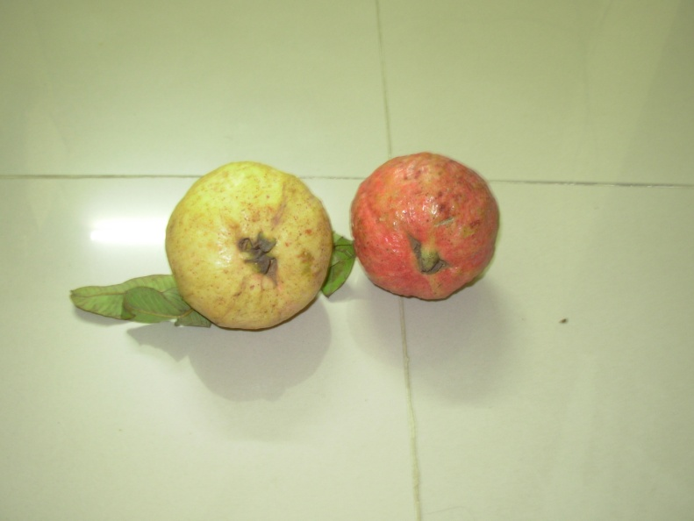
Allahabad Surakha Guava
- Sitapur District:
Under DASP project visit was made to villages viz. Bijuaman (Mujaffarpur) and Tikauli (Kabran) where goat rearing and Middle White Yorkshire Piggery units were seen. Jamunapuri breed of goat have been given to the farmers. These goat give 2 litres per day in 3 times. Lactation is 2 times a year. Other interventions in this district are demonstration plots of tissue culture banana, gourd vegetables on machan, Allahabad Safed Guava demonstration on farmers field.

- Lucknow District:
Saghan Mini Dairy Yojana – Project grant: ` 12.018 crore; Expenditure: ` 12.018 implemented by Pradeshik Cooperative Dairy Federation Ltd. (PCDF).

This is an ambitious project of employment generation and increasing milk production through induction of high yielding milk animals in all the 72 districts of Uttar Pradesh.

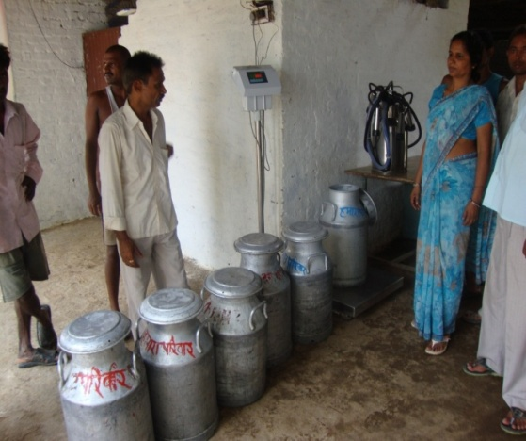
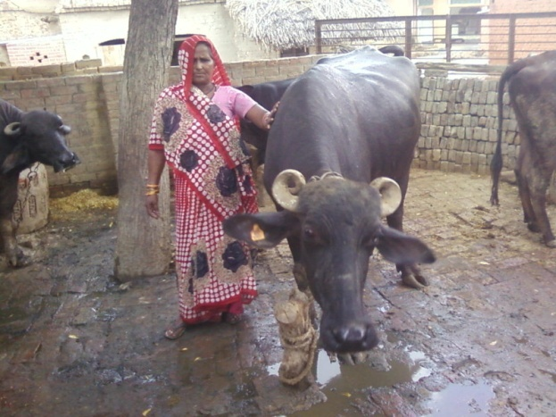
Murrah Buffalo Milk Collection centre
The dairy farmer purchases upgraded two murrah buffaloes or two cross bred HF or two crossbred Sahiwal cows of 1st or 2nd lactation at a cost of ` 40,000/- (yielding 8 litres / day for buffaloes 10 litres per day) . The subsidy is Rs.7500/- for OBC/General category and Rs.10,000/- for SC/ST for two animal unit. The rest of the cost has been met by bank loan. The District milk union is the nodal agency to implement this project to provide backward and forward linkages to the dairy farmers. Milk and milk products are sold under ‘Parag’ brand name. Field visit was made to Amethi village in Lucknow district wherein NIRD Monitoring Team Member could interact with the dairy farmers and the Branch Manager of Union Bank of India to have a feed back about this project. It is understood that the scheme has been accepted by both the farmers and the bank also as the branch manager is happy about the recovery performance under this scheme. Visit was made to Automatic Milk Collection Unit also where the price is paid based on Fat and Solid Not Fat (SNF) percentage. The milk union has installed Bulk Milk Cooler of the capacity of 2000 litre with Generator back up which gets milk collection both in the morning and evening. This may be considered as one of the successful schemes under RKVY in Uttar Pradesh.

Action Points:

Following suggestions are made for better implementation of RKVY projects in Uttar Pradesh.

- All the Project Implementing Agencies (PIA’s) may prepare project wise output / impact of completed projects with case studies containing good photographs.
- At present UPDASP does not submit the sector wise allocations and progress made in each sector which makes difficult for monitoring. Hence, it is suggested that separate projects indicating district wise physical and financial targets for each sector may be submitted.
- USDASP should create a Marketing Network for the products prepared by SHG’s promoted by them.
- All PIA’s should maintain a database wherein benchmark data of pre-intervention of RKVY and also data of post intervention are entered. This will help for proper impact assessment or evaluation study at a later period.
- NAFED should come out with the plan for marketing of organic products on a sustainable way so that even when the project period is over, attractive price is made available to the organic farmers.
- AFC should give more attention for creating one model farm in each block to disseminate the farm technologies through farmer to farmer extension method for wider adoption.
- In case or energisation of pumpset scheme implemented by Minor Irrigation Department, the PIA should submit details of district wise beneficiaries to the Nodal Agency of the RKVY.
- NAFED should promote vermi-composting along with NADEP compost method.
- Cow Pit Pat (CPT) method of composting propagated by NAFED should be validated by a recognized agriculture university.

04.01.2011

Table 1: Year wise allocation releases and expenditure

(As on 15.09.2010) (` crore)
S. No. | Year | Allocation | Previous Balance | Release by GoI | Total Release | Exp. During year | % Exp. (Col. 7/6) | Balance at the end of year
(1) | (2) | (3) | (4) | (5) | (6) | (7) | (8) | (9)
1. | 2007-08 | 116.15 |  | 103.90 | 103.90 | 0.00 | - | 103.90
2. | 2008-09 | 316.57 | 103.90 | 316.57 | 420.47 | 296.28 | 70.46 | 124.19
3. | 2009-10 | 390.97 | 124.19 | 390.97 | 515.16 | 333.90 | 64.81 | 181.26
4. | 2010-11 | 635.92 | 181.26 | 373.41 | 554.67 | 211.53* | 38.13
 |  | 1459.61 |  | 1184.85 |  | 841.71
*Expenditure up to 15.09.2010. Govt of UP expects to utilize the balance of ` 343.14 crore before March 2011.

Table 2: Abstract of SLSC wise Details of Projects approved under RKVY

(As on 15.09.2010) (Amount in lac `)
Sl. No. | Date of SLSC | Approved Amount | Expenditure
 | 03.03.2008 | 10900.36 | 10390.00
 | 17.10.2008 | 38522.71 | 27782.26
 | 03.02.2009 | 126690.93 | 26187.23
 | 27.07.2009 | 2467.68 | 2181.52
 | 27.12.2009 | 7569.07 | 4471.35
 | 29.04.2010 | 57168.72 | 13158.65
 | Total | 243319.47 | 84171.01

Table 3: Year wise / Department wise expenditure under RKVY

(As on 15.09.2010) (Amount in crore `)
Sl. No. | PIA wise Deptt. / Institutions | Expen.  2008 – 09 | Expen.  2009 – 10 | Proposed  2010 – 11 | Total | %
 | Agriculture | 40.84 | 113.74 | 289.25 | 443.83 | 30.66
 | AFC | 12.02 | 12.02 | 43.90 | 67.94 | 4.69
 | NAFED | 20.67 | 1.70 | 14.98 | 37.35 | 2.58
 | Animal Husbandry | 4.00 | 19.14 | 35.88 | 59.02 | 4.08
 | Saghan Mini Dairy | 12.77 | 12.02 | 15.57 | 40.36 | 2.79
 | Horticulture | 3.97 | 43.47 | 39.10 | 86.54 | 5.98
 | Minor Irrigation | 104.09 | 16.02 | 125.75 | 245.86 | 16.99
 | Irrigation (TW & Canal) | 0.00 | 0.00 | 54.98 | 54.98 | 3.80
 | Remote Sensing Application Centre (RSAC) | 0.00 | 2.84 | 0.00 | 2.84 | 0.20
 | Sericulture | 0.00 | 10.96 | 20.41 | 31.37 | 2.17
 | SIMA Rehmankhera | 0.02 | 1.66 | 4.34 | 6.02 | 0.42
 | Beej Vikas Nigam | 5.00 | 11.62 | 50.52 | 67.14 | 4.64
 | UP Agro | 3.92 | 3.99 | 24.93 | 32.84 | 2.27
 | UPDASP | 70.00 | 68.70 | 70.00 | 208.70 | 14.42
 | Agri. Universities | 9.65 | 16.02 | 17.70 | 43.37 | 3.00
Total |  | 296.28 | 333.90 | 817.18 | 1447.36 | 100.00

Table 4: Abstract of SLSC wise details of Projects approved from 2007-08 to 2010-11 in Page no. 15 to 37.

Table 5: Time lag in fund release at different levels for the year 2009-10 and 2010-11 is given in excel file



Table 4: Details of SLSC wise Projects approved in 1st SLSC dated 03-03-2008
Project S.No | Department | Stream | Name of the Project | Amount approved by SLSC  (` in lac) | Remarks
1 | Minor Irrigation | I | Electrification of 21120 private diesel tube-well | 5000.00
2 | Agriculture | I | Facility of Sprinkler set & Drip Irrigation Projects in 141 Blocks where, under down falling ground water level | 479.40 | Not executed, to be desanctioned
3 | Agriculture | II | Strengthening of Soil Testing Labs | 600.00
4 | Agriculture | II | Scheme for land reclamation in Katri Area of Ramganga river. | 100.00
 |  |  | Total | 1179.40
5 | Neda | I | Establishment of 500 solor photo volteak irrigation pumps in Bundelkhand and other regions. | 355.56 | Not executed, to be desanctioned
6 | NDUAT Faizabad | I | Foundation/certified seed production | 363.40
7 | CSAUAT Kanpur | I | Foundation/certified seed production | 602.00
8 | Animal Husbandry | I | Strengthening of deep frozen Semen Production centre, training & extension programme | 400.00
9 | Horticulture | I | Strengthening of seed farms training canter, exposure visit of farmers & fencing of new orchards | 400.00
10 | Fisheries | I | Development of fisheries areas | 400.00
11 | AFC | I | Customized Farmers Training & Extension Activities online monitoring | 200.00
 |  |  | Total | 8900.36
12 | Beej Vikas Nigam | II | Strengthening of Seed Processing Unit | 500.00
13 | UP Agro | II | Establishment of Agrimart at Lucknow & Hapur | 433.00
14 | NAFED | II | Certification of Organic Agriculture Management System. | 1067.00
 |  |  | Total | 2000.00
 |  |  | G. Total (Stream I &Stream II) | 10900.36

Project approved in 2nd SLSC dated 17-10-2008
Project S.No | Department | Stream | Name of the Project | Amount approved by SLSC | Remarks
1 | Agriculture Department | I | 1-Soil Health Improvement Programme | 2664.000
2 | Agriculture Department | I | 2-Strengthening of Soil Survey and distribution of soil profile (health cards) | 44.000
3 | Agriculture Department | I | 3-Strengthening of IPM Programme | 283.000
4 | Agriculture Department | I | 4-Strengthening of Extension System of Niyay Panchayat. | 1700.000 | Desanctioned, Amount diverted to Katri Land reclamation project
5 | Agriculture Department | I | 5-Exposure Visit & Agriculture Technology Awareness Scheme | 345.600
6 | Agriculture Department | II | 1- Strengthening of Govt. Farm & Seed production system | 1365.990
7 | Agriculture Department | II | 2- Strengthening of Agriculture Seed Storage at Block Level. | 1219.500
8 | Agriculture Department | II | 3-Strengthening of Seed Testing Labs. | 162.000
9 | Agriculture Department | II | 4-Scheme of adoptive Trials/Demonstrations and organizing farmers at RATDS | 45.790
10 | Agriculture Department | II | 5-Assessment of crop yield in demonstrations in various schemes | 16.100
11 | Agriculture Department | II | 6-Strengthening & renovation of Communication. & Training infra. HQ | 210.360
 | Agriculture Department | II | Total | 8056.340
12 | AFC | I | 1-Customized Farmers Training Extension Activities online monitoring | 1002.000
13 | NAFED | I | 1-Certification of Organic Agriculture Management System. | 1000.000
14 | Animal Husbandry | I | 1-Strengthening of artificial in-cementation centre | 1603.180
15 | Animal Husbandry | II | 1-Foundation Bar-seem seed production | 34.130
 | Animal Husbandry |  | Total | 1637.310
16 | PCDF | I | 1-Saghan Mini Dairy Yojna | 1201.870
17 | PCDF | II | 1-Vehicle Tracking System | 74.970
 | PCDF |  | Total | 1276.840
18 | Horticulture | I | 1-Production of high value Vegetable Crops through nursery production in Low tunnels | 2713.000
19 | Horticulture | I | 2-Onion Production with the introduction of improved varieties | 572.400
20 | Horticulture | II | 1-Strengthening of nursery/seed farms | 300.000
21 | Horticulture | II | 2-Strengthening of Govt. garden & flower nursery | 400.000
 | Horticulture | II | Total | 3985.400
22 | Fisheries | I | 1-Development of demo sites for Integrated Fish Farming | 112.000 | Not taken up
23 | Fisheries | I | 2-Establishment of 18 Model Fish Market. | 283.000
24 | Fisheries | II | 1-Fish Seed Production at Govt. Fish Farms | 65.000
25 | Fisheries | II | 2-Establishment of Training and awareness centre at Badalpur (GB Nagar) | 15.000
26 | Fisheries | II | 3-Development of departmental water bodies | 58.000
 | Fisheries | II | Total | 533.000
27 | Minor Irrigation | I | 1-Energigation of 7955 tube-well | 5409.000
 | Minor Irrigation | I | Total (I) | 22899.89
28 | Beej Vikas Nigam | II | 1-Strengthening of Seed Processing Plant | 353.200
29 | SIMA Rehmankhera | II | 1-Farm mechanization & Training Inst. Rehmankhera | 45.640
30 | RSAC | II | 1-Strengthening of crop coverage | 108.430
31 | UP Agro | II | 1-Strengthening and Modernization of Animal Feed production unit. | 239.000
32 | UP DASP | I | 1-Promoting intensification and diversification of Agricultural production & increasing farmer access to expanding market opportunities | 13924.250 | Blance Amt. of Rs. 6924.25 to be desanctioned
 | Administrative expenses | I | DAP/SAP | 0.000
 | Administrative expenses | I | Contingency | 316.000
33 | CSAUAT Kanpur | II | 1-Strengthening of University farms breeder/foundation seed production | 350.00 | Not taken up
34 | CSAUAT Kanpur |  | 2-Participatory seed production programme | 50.00 | Rs.50.00 lakh provided from NFSM
35 | NDUAT Faizabad | II | 1-Strengthening of infrastructure for breeder /foundation seed production | 50.00 | Not taken up
36 | SVBPUAT Meerut | II | 1-Production of breeder/foundation seeds and strengthening of seed farms at University | 150.00 | Not taken up
37 | AAIDU Allahabad | II | 1-Stengthening of seed production farms of University | 5.00 | Not taken up
 | AAIDU Allahabad | II | 2-Institutional charges for UPCAR | 6.05 | To be desanctioned
38 | SVBPUAT Meerut | II | 1-Expansion of mushroom research lab | 20.00 | Not taken up
39 | NDUAT Faizabad | II | 1-Integrated management of plaster moulds of milky mushroom | 5.00
 | NDUAT Faizabad | II | 2-Institutional charges for UPCAR | 0.25 | To be desanctioned
 |  |  | Total (II) | 15622.820
 |  |  | G. Total (I+II) | 38522.710

Project approved in 3rd SLSC dated 03-02-2009
Project S.No | Department | Stream | Name of the Project | Amount approved by SLSC | Remarks
1 | Agriculture | I | 1- Soil Health Improvement Programme | 4563.07
2 | Agriculture |  | 2- Strengthening of Soil Survey and distribution of soil profile (health cards) | 45.00
3 | Agriculture |  | 3- Strengthening of Extension System at Nyay Panchayat | 4384.00 | Not taken up
4 | Agriculture |  | 4- Certification of organic Agriculture Management Systems | 398.00
5 | Agriculture |  | 5- Exposure Visit & Agriculture Technology Awareness Scheme | 427.07
6 | Agriculture |  | 6- Customized Farmers Training Extension Activities online monitoring | 2088.21
7 | Agriculture |  | 7- Strengthening of IPM Programme | 700.00 | Blance Amt. of Rs. 350.00 to be desanctioned
8 | Agriculture |  | 8. Scheme for land reclamation in Katri Area of Ramganga river.(For the year 2008-09) | 600.00
 | Agriculture |  | 9. -do- (For the year 2009-10) | 1800.00
9 | Agriculture |  | 10. Establishment of seed stores for sale of certified seeds and technology extension (71 Stores) | 148.200 | Not taken up
10 | Agriculture | II | 1- Strengthening of Govt. Farm & Seed production system | 1175.30 | Taken up during 2010-11
11 | Agriculture |  | 2- Safe storage of seeds at block level seed stores | 487.80 | Not taken up
12 | Agriculture |  | 3- Scheme of adoptive Trials/Demonstrations and organizing farmers at RATDS | 44.25
13 | Agriculture |  | Strengthening of soil testing lab.(2008-09) | 577.36 | Balance Amt. of Rs. 138.10 to be desanctioned
14 | Agriculture |  | 4-Assessment of crop yield in demonstrations in various schemes | 18.20 | Not taken up
15 | Agriculture |  | 5- Strengthening & renovation of Communication. & Training infra. HQ | 245.41 | Taken up during 2010-11
16 | Agriculture |  | 6- Strengthening of seed processing unit Beej Vikas Nigam | 1055.31 | --
17 | Agriculture |  | 8- Farm mechanization & Training State Agri. Mang. Inst. Rahamankhara | 292.00
18 | Agriculture |  | 8-Construction of kisan museum and farmers hostel | 2066.29 | Not taken up
19 | Agriculture |  | 9- Establishment of pesticide residue analysis lab in U.P. | 377.00 | Not taken up
 |  |  | Total | 21492.47
20 | Animal Husbandry | I | 1- Establishment of Goat Farming units at district level | 120.70 | --
21 | Animal Husbandry |  | 2- Establishment of Pig Farming units at district level | 80.41 | --
22 | Animal Husbandry |  | 3- Five days training & extension facilities to the live stock owners under RKVY | 526.69 | Taken up during 2010-11
23 | Animal Husbandry |  | 4- Five days training & extension facilities to the live stock owners under RKVY ( For the year 2008-09) | 170.74
24 | Animal Husbandry |  | 5- Serosurveillance, Molecular Diagnosis and Epidemiological Studies on Avian Influenza (Bird Flu) Virus (Izatnagar) Addl. Proj. | 635.95 | Not taken up
25 | Animal Husbandry | II | 1. Strengthening of Institute vetenery biological Lucknow | 1160.15 | Not taken up
26 | Animal Husbandry |  | 2. Strengthening of Irrigation and Irrigation channel systems at Govt. farms. | 628.00 | Not taken up
27 | Animal Husbandry |  | 3. Prod. of foundation fodder seed at Animal Husbandry Farms | 423.01 | Balance Amt. of Rs. 28.54 to be desanctioned
28 | Animal Husbandry |  | 4- Foot and mouth disease control programme | 1102.52
29 | Animal Husbandry |  | 5- Pashuwon me Rabies rog ki roktham avam Rabies sankraman se mreteu rokene ki yojana | 71.20
30 | Animal Husbandry |  | 6- Strengthening of Model Training Cum-production centre B.K.T. Lko. | 510.52 | Desanctioned
 | Animal Husbandry |  | Total | 5429.89
31 | PCDF (Dairy) |  | Saghan Mini Dairy Yojna | 2498.88 | Balance Amt. of Rs. 1297.01to be desencitned
32 | Horticulture & Food Processing | I | 1- Production of high value Vegetable Crops through nursery production in Low tunnels | 3391.25 | Taken up during 2010-11
33 | Horticulture & Food Processing |  | 2- Onion Production with the introduction of improved varieties | 715.00 | Taken up during 2010-11
34 | Horticulture & Food Processing |  | 3- Protection of newly planted orchard with barbed wire fencing | 2130.00 | Not taken up
35 | Horticulture & Food Processing |  | 4- Seed Production of Garlic at Farmer’s Field | 500.00 | Not taken up
36 | Horticulture & Food Processing |  | 5- Promotionn of bee-keeping | 2587.92 | Not taken up
37 | Horticulture & Food Processing | II | 1- Strengthening of nursery/seed farms/elite gardens | 1000.00 | --
38 | Horticulture & Food Processing | II | 2- Establishment of Tissue Culture Lab | 2002.25 | Not taken up
39 | Horticulture & Food Processing | II | 3- Training centre with Hostel facility | 1000.00 | Desanctioned
40 | Horticulture & Food Processing | II | 4- BLF/Computer operators | 625.20 | Not taken up
 | Horticulture & Food Processing | II | Total | 13951.62
41 | Fisheries | I | 1Development of demonstration sites for Integrated Fish Farming | 112.00 | Taken up during 2010-11
42 | Fisheries |  | 2-Development/Establishment of Modern Fish Market. | 189.00 | Taken up during 2010-11
43 | Fisheries | II | 1- Fish Seed Production at Govt. Fish Farms | 116.10 | Taken up during 2010-11
44 | Fisheries |  | 2- Establishment of Training and awareness cntre at Badalpur (GB Nagar) | 20.00 | Taken up during 2010-11
45 | Fisheries |  | 3- Creation of Infrastructure to support Fisheries Cooperatives | 20.00 | Not taken up
46 | Fisheries |  | 4- Farmers data base and resource evaluation | 128.00 | Not taken up
 | Fisheries |  | Total | 585.10
47 | Minor Irrigation | I | 1- Tubewell energization | 10880.00 | Desanctioned
48 | Minor Irrigation |  | 2- Purchase of Rig Machine | 1490.00 | Desanctioned
49 | Minor Irrigation |  | 3. Construction of Blast well in rocky areas (For the year 2008-09) | 450.00 | --
50 | Minor Irrigation | II | Strengthening of Minor Irrigation training centre | 250.00 | Desanctioned
 |  |  | Total | 13070.00
51 | Irrigation (Tubewell) | I | 1. Construction of additional pipeline on 2500 State tubewells of 1.0 cusec capacity | 2247.50 | Not taken up
52 |  |  | 2. Replacement of P.V.C. pipeline on 1000 tubewells of C.C. pipe line | 1840.00 | Not taken up
53 |  |  | 3. Relaying & Modernisation of guls of 4000 tubewells | 4680.00 | Taken up during 2010-11
54 |  |  | 4. Modernisation of 4.0 km. PVC pipeline including face lifting of pump house/tank on 1000 tubewells | 920.00 | Taken up during 2010-11
55 |  |  | 5. Modernisation of 2.0 km. PVC pipeline including face lifting of pump house/tank on 1000 tubewells | 520.00 | Taken up during 2010-11
 |  |  | Total | 10207.50
56 | Irrigation | I | 1. Removal of seepage and water logging near canals | 16621.46 | To be taken during 2010-11for Rs. 3743.50 & balance Amt. Rs. 12977.96 to be desanctioned
 |  |  | Total | 16621.46
57 | Ground water | I | 1. Instrument and equipments required for Ground Water survey investigation and exploratory drilling | 1461.25 | Not taken up
58 | Sericulture | I | 1- Strengthening of Silk Koya production, koya marketing & spinning units and establishment of silk bank and marketing information center.(For the year 2008-09) | 1096.80 | --
 |  |  | 2. -do- (For the year 2009-10) | 748.40
 |  |  | Total | 1845.20
59 | PCF | I | 1- Creation of additional storage capacity at buffer godown | 1413.00 | Desanctioned
60 |  |  | 2- Strengthening/Renovation of 3 lac MT. godowan | 1200.00 | Desanctioned
 |  |  | Total | 2613.00
61 | U.P. State warehousing Corporation | I | Establishment of 1.85 Lac MT. new godowns | 9063.98 | Desanctioned
62 | PACS | I | 1.Strenghening/renovation of 1000 godowns of primary Agriculture credit Cooperative Societies | 1000.00 | Desanctioned
63 | UP DASP | I | 1.Promoting intensification and diversification of Agricultural puoduction & increasing farmer access to expanding market opportunities | 15121.61 | Balance Amt. of Rs. 8251.61to be decanctioned
 | SAUS
64 | C.S.A.U.A.T. Kanpur. | I | 1. Quality seed production of Indian and exotic major carps and catfish. | 20.00
65 | C.S.A.U.A.T. Kanpur. |  | 2. Participatory vegetable quality seed production to enhance vegetable production in U.P. | 20.00 | --
66 | C.S.A.U.A.T. Kanpur. |  | 3. Production of quality chicks from parental stock to enhance the poultry production in U.P. | 100.00 | --
 | C.S.A.U.A.T. Kanpur. |  | 4. Institutional charges for UPCAR (Processing, coordination, monitoring and concurrent/mid-term evaluation) @ 1 % | 1.20 | To be desanctioned
 |  |  | Total | 141.20
67 | N.D.U.A.T. Faizabad. | I | 1. Conservation of superior germplasm through establishment of modernization frozen semen bank for genetic improvement of cattle and buffalo in Eastern U.P. | 150.00 | --
68 |  |  | 2. Studies on epidemiology prevention and control of major diseases of animals in purnaduchal U.P. | 60.00 | Not taken up
69 |  |  | 3. Strengthening of university poultry farm for vocational training of rural youth, women and weaker section of the society | 50.00
70 |  |  | 4. Establishment of Soil Health Clinic | 20.00 | Not taken up
71 |  |  | 5. Enhancing productivity of problematic soil of Eastern U.P. using innovative tillage technology | 15.00 | Not taken up
72 |  |  | 6. Management of vector borne legume viruses by Boerhavia diffusa glycoprotein | 25.00
73 |  |  | 7. Genetic improvement and performance recording of Buffalo in Eastern U.P. | 150.00
74 |  |  | 8. Establishment of quality bio-fertilizer production unit | 20.00 | Not taken up
75 |  |  | 9. Alleviation of water logging and salinity in canal commands through drainage and judicious water management : An operational research project | 30.00 | Not taken up
76 |  |  | 10. Production and supply of mushroom spawn to farmers | 15.00
 |  |  | 11. Institutional charges for UPCAR (Processing, coordination, monitoring and concurrent/mid-term evaluation) @ 1 % | 5.35 | To be desanctioned
 |  |  | Total | 540.35
77 | S.V.B.P.U.A.T. Merrut. | I | 1. Production and Multiplication of superior germplasm of Murrah Buffalo | 100.00 | --
78 |  |  | 2. Establishment of Carp hatchery for quality fish seed production in Western U.P. | 20.00 | --
79 |  |  | 3. Genetic improvement through biotechnological interventions in major crops suitable for changing climatic conditions of Western U.P. | 150.00 | --
80 |  |  | 4. Development of an ideal module for the sustainable management of mealy bugs of major vegetables of U.P. | 15.00 | --
81 |  |  | 5. Development of an ideal module for the sustainable management of white grub of Sugarcane for Western U.P. | 50.00 | --
82 |  |  | 6. Research & training unit of organic farming of major food crops (Wheat, Basmati rice, Urd, Okra, Vegetable pea and Til) for sustainable production & soil health | 15.00 | Not taken up
83 |  |  | 7. Development of high yielding and disease resistant varieties with good nutritional qualities in forage crops | 25.00 | Not taken up
84 |  |  | 8. Assessment and mitigating the impact of climatic change on food grain production and soil health in western U.P. | 20.00 | Not taken up
85 |  |  | 9. Development of aerobic rice using biotechnological tools | 55.00 | --
86 |  |  | 10. Enhancing yield potential of major field crops by incorporation of disease resistance | 65.00 | Not taken up
87 |  |  | 11. Establishment of bio-control unit for production and demonstration of bio-agents at Farm Science Centers to facilitate the IPM practices among the farming community | 172.25 | Taken up during 2010-11
 |  |  | 12. Institutional charges for UPCAR (Processing, coordination, monitoring and concurrent/mid-term evaluation) @ 1 % | 6.87 | To be desanctioned
 |  |  | Total | 694.12
88 | A.A.I.D.U. Allahabad | I | 1. Farmers' participatory foundation seed production programme | 300.00 | --
89 |  |  | 2. Farmers' participatory foundation seed production programme in pulses (Chickpea, Pegeonpea, Moong bean, Urd bean and Field pea) | 15.75 | --
90 |  |  | 3. Development of high yielding pulses (Black gram and Moong bean), Oilseed (Eureca and Linseed) and Maize varieties | 30.00 | Not taken up
91 |  |  | 4. Establishment of soil health clinic | 35.00 | Not taken up
92 |  |  | 5. Enhancing productivity through fisheries and soft water pearl production | 10.00 | Not taken up
93 |  |  | 6. Bio-intensive insect pest management strtegies in chickpea under nothern-eastern U.P. | 10.00 | --
 |  |  | 7. Institutional charges for UPCAR (Processing, coordination, monitoring and concurrent/mid-term evaluation) @ 1 % | 4.08 | To be desanctioned
 |  |  | Total | 404.83
94 | P. D. D. U. Mathura | I | 1. Multiplication and conservation of Hariana cattle & Bhadawari buffalo through male germplasm by modern techniques of artificial insemination(the year 2008-09) | 40.00 | --
 |  |  | 2. -do- (For the year 2009-10) | 75.00
95 |  |  | 3. Establishing State Referral Veterinary polyclinic(For the year 2008-09) | 25.00 | Not taken up
 |  |  | 4. -do- (For the year 2009-10) | 25.00
96 |  |  | 5. Quality fodder seed production in the University(For the year 2008-09) | 30.00 | --
 |  |  | 6. -do- (For the year 2009-10) | 50.00
97 |  |  | 7. Demonstration unit for piggery farming (For the year 2008-09) | 2.00 | Not taken up
 |  |  | 8. -do- (For the year 2009-10) | 4.00
98 |  |  | 9. Modrnization and mechanization of instructional dairy farm (For the year 2008-09) | 35.00 | Not taken up
 |  |  | 10. -do- (For the year 2009-10) | 100.00
99 |  |  | 11. Pashu Gyan Chaupal for field health and production interventions(For the year 2008-09) | 25.00 | --
 |  |  | 12. -do- (For the year 2009-10) | 50.00 | Not taken up
100 |  |  | 13. Low input poultry research & training centre | 50.00 | Not taken up
 |  |  | 14. -do- (For the year 2009-10) | 50.00
101 |  |  | 15. Establishment of a fish seed production unit(For the year 2008-09) | 25.00 | --
 |  |  | 15. -do- (For the year 2009-10) | 50.00 | --
 |  |  | 16. Institutional charges for UPCAR (Processing, coordination, monitoring and concurrent/mid-term evaluation) @ 1 % | 4.04 | To be desanctioned
 |  |  | Total | 640.04
 |  |  | S.A.U. Total | 2420.54
102 | UP Agro | II | Establishment of Agrimart | 5150.00 | Not taken up
103 | Land Development and Water Resources Department | II | Construction of training centre at Aliganj, Lucknow | 498.60 | Desanctioned
104 | UPCAR | II | One time grant for Establishment of Genebank, Phytosanitory lab, Refferal lab, IPR cell, ARIS cell, Display gallery and Strengthening of UPCAR | 2500.00 | Proposed to be desanctioned
105 | RSAC | II | 1. Crop condition Assessment & production assessment | 176.20 | --
 | Administrative 1% |  |  | 983.63
 | Grand. Total (Stream I + II) |  |  | 126690.93

Project approved in 4th SLSC dated 27-07-2009
Project S.No | Department | Stream | Name of the Project | Amount approved by SLSC | Remarks
1 | Agriculture | I | 1. Distribution of seed minikit for Kharif crops due to delayed Monsoon. (addl. Project) | 2453.22 | Blance Amt. of Rs. 260.38 to be decancited
2 | N.D.U.A.T. Faizabad. | I | 1. Development of nutrient management options to enhance survival recovery and yield of submerged SUB1-varieties.(addl. Project) | 12.21 | --
3 | N.D.U.A.T. Faizabad. | I | 2. Promoting Swarna Sub 1, a Submergence Tolerant Rice Variety to alleviate poverty of Flood-Prone Rice Farmers of Eastern U.P. (addl. Project) | 2.25 | --
 |  |  | Total | 2467.68

Project approved in 5th SLSC dated 21-12-2009
Project S.No | Department | Stream | Name of the Project | Amount approved by SLSC | Remarks
 | Agriculture | I | 1. Distribution of additional 54,900 seed minikits of Toria in drought affected regions/districts within approved financial allocations. | 25.78
1 | Agriculture | I | 2.Additional Seed Subsidy OnI.C.D.P.-Wheat (Sub project of MMA) under RKVY. | 659.76 | Blance Amt. of Rs. 81.36 to be decancited
2 | Agriculture | I | 3. Krishni River Water Recharging Project. (Scheme Under MMA) | 64.96 | --
 | Agriculture | I | 4.Establishment and Management of State Call Center for Department of Agriculture | 7.50 | Expen. Included under administrative expness
 | Beej Vikas Nigam | I | 1. Strengthening of seed processing units(Cost escalation) | 349.78
 | U.P. Agro | I | 1. Establishment of Agrimart at Lucknow,Hapur &Ghaziabad (Cost escalation) | 159.83
3 | Minor Irrigation | I | 1-Project for Minor Irrigation Works (Deep boring, medium deep tube-well, Dr. Bhim Rao Ambedkar tube-well & Dr. Ambedkar community tube-well) | 6235.72 | --
 | N.D.U.A.T. Faizabad. | I | 1.Conservation of superior germplasm through establishment of modernization frozen semen bank for genetic improvement of cattle and buffalo in Eastern U.P. (Cost escalation) | 42.00 | --
 | Fisheries | I | 2- Establishment of Training and awareness cntre at Badalpur (GB Nagar) (Cost escalation) | 23.74 | Being taken up during 2010-11
 |  |  | Grand Total | 7569.07

Project approved in 6th SLSC dated 29-04-2010
Project S.No | Department | Stream | Name of the Project | Amount approved by SLSC
1 | CSAU Kanpur | I | 1- Production of Quality Chicks to enhance the Poultry Production in UP through training & demonstration | 79.29
2 | CSAU Kanpur | I | 2- Participatory Vegetable Quality Seed Production to enhance Vegetable Production in UP | 34.50
3 | CSAU Kanpur | I | 3- Quality Seed Production of Indian & Exotic Major Carp and Cat Fish | 44.50
4 | CSAU Kanpur | II | 4-Participatory Seed Production of the Field Crops | 300.00
 | CSAU Kanpur |  | Total | 458.29
5 | N.D.U.A.T., Faizabad | I | 1-Conservation of superior Germless through establishment of modernized Frozen Semen Bank for Genetic Improvement of Cattle & Buffalo in Eastern UP | 161.00
6 | N.D.U.A.T., Faizabad | I | 2-Strengthening of quality seed production programme of field crops in eastern UP | 221.64
7 | N.D.U.A.T., Faizabad | I | 3-Production and supply of Mushroom spawn to farmers | 12.90
8 | N.D.U.A.T., Faizabad | I | 4-Genetic improvement and performance recording of Buffalo in eastern UP | 186.50
9 | N.D.U.A.T., Faizabad | I | 5-Development of Nutrient management Option to Enhance Survival Recovery & Yield of Sub-Merged Sub-1varities | 11.90
10 | N.D.U.A.T., Faizabad | I | 6-Management of vector borne legume viruses by Boerhavia diffusa glycoprotein | 10.00
11 | N.D.U.A.T., Faizabad | I | 7-Promoting Swarna Sub 1, a Submergence Tolerant Rice Variety to alleviate poverty of Flood-Prone Rice Farmers of Eastern U.P. | 10.00
12 | N.D.U.A.T., Faizabad | I | 8-Strengthening of university poultry farm for vocational training of rural youth, women and weaker section of the society | 50.00
13 | N.D.U.A.T., Faizabad | II | 9-Integrated management of Plaster Moulds of Milky Mushroom | 10.80
 |  |  | Total | 674.74
14 | AAIDU Allahabad | I | 1-Farmers Participatory foundation seed production programme | 200.00
15 | AAIDU Allahabad | I | 2-Farmers Participatory foundation seed production programme in Pulses | 9.95
16 | AAIDU Allahabad | I | 3-Bio-intensive insect pest management Strategies in Chick pea under North Eastern UP | 10.00
 | AAIDU Allahabad | I | Total | 219.95
17 | S.B.B.P. University Meerut | I | 1- Production and multiplication of superior germ plasm of Murrah Buffalo | 116.80
18 | S.B.B.P. University Meerut | I | 2.Establishment of Carp hatchery for quality fish seed production in Western U.P. | 10.00
19 | S.B.B.P. University Meerut | I | 3.Genetic improvement through biotechnological interventions in major crops suitable for changing climatic conditions of Western U.P. | 100.00
20 | S.B.B.P. University Meerut | I | 4.Development of an ideal module for the sustainable management of mealy bugs of major vegetables of U.P. | 5.00
21 | S.B.B.P. University Meerut | I | 5. Development of an ideal module for the sustainable management of white grub of Sugarcane for Western U.P. | 15.00
22 | S.B.B.P. University Meerut | I | 6.Development of aerobic rice using biotechnological tools | 15.00
 | S.B.B.P. University Meerut | I | Total | 261.80
23 | PDDUVU MATHURA | I | 1- Multiplication and conservation of Haryana cattle & Bhadawari buffalo through male germless by modern technique of artificial insemination | 50.00
24 | PDDUVU MATHURA | I | 2- Quality fodder seed production in the university | 25.00
25 | PDDUVU MATHURA | I | 3- Pashu Gyan Chaupal for field health and production interventions | 50.00
26 | PDDUVU MATHURA | I | 4- Establishment of fish seed production unit | 30.00
 | PDDUVU MATHURA | I | Total | 155.00
 |  |  | Total University | 1769.78
27 | Department of Agriculture | I | 1- Soil Health Improvement Programme | 6359.99
28 | Department of Agriculture | I | 2- Strengthening of Soil Survey Programme | 72.50
29 | Department of Agriculture | I | 3- Exposure Visit and Agriculture Technology awareness scheme | 500.00
30 | Department of Agriculture | I | 4-Strengthening of IPM Programme | 602.45
31 | Department of Agriculture | I | 5- Scheme for land reclamation in Katri Area | 2500.00
32 | Department of Agriculture | I | 6- Strengthening and Renovation of Rajkiya Krishi Vidhalay, Bulandshahar for the extension of technology, communication and training | 133.22
33 | Department of Agriculture | I | 10-Bundelkhand Package | 3749.95
34 | Department of Agriculture | II | 7- Adapted Trials/Demonstration & Organizing Kisan Mela at RATDS (Soil Rech & Survey) | 51.14
35 | Department of Agriculture | II | 8- Strengthening of Govt Agriculture Farms and seed production | 1897.00
36 | Department of Agriculture | II | 9-Assessment of Crop Yield in demonstrations in various scheme (Statistics) | 32.60
37 | Department of Agriculture | II | 11- Capacity Building and Training for Technical personnel (Training) | 411.86
 |  |  | G.Total | 16310.71
38 | NAFED | I | 1-Adoption and Certification of organic agriculture management system | 1269.53
39 | AFC | I | 1-Customized Farmers Training and Extension and Online Agriculture Monitoring through application of ICT at Block level | 3644.45
40 | AFC | I | 2- Enhancing production and productivity of wheat by proper placement of seed and fertilizer through line sowing in selected Estern districts of UP | 859.10
 |  |  | Total | 4503.55
41 | SIMA Lucknow | II | 1-Training Programme for Development quality nursery and to incourage medicinal plant. | 71.53
42 | SIMA Lucknow | II | 2-Refreshment (skill & knowledge) of soil conservation technical employees | 148.99
43 | SIMA Lucknow | II | 3-Stregthening of Govt Agriculture Farm at Rehmankhera & Sehlamau | 90.44
 | SIMA Lucknow | II | Total | 310.96
44 | Beej Vikas Nigam | II | 1- Strengthening Seed Processing Plant at Distt. Ambedkar Nagar, Bareilly | 302.17
45 | Beej Vikas Nigam | I | 2- Production of certified seed at the level of seed growers (for the year 2009-10) | 2373.00
46 | Beej Vikas Nigam | I | 3-Production of certified seed at the level of seed growers | 2267.83
 |  |  | Total | 4943.00
47 | Animal Husbandry | I | 1-Increased coverage under A.I. | 374.00
48 | Animal Husbandry | I | 2-Broillers bird keeping scheme | 79.87
49 | Animal Husbandry | II | 3-Stregthening of Pig\Goat and Sheep breeding govt.farms | 488.14
50 | Animal Husbandry | II | 4- Strengthening of veterinary Biological Institute, Badshahbagh Lucknow to increase quality of Produced vaccine production | 250.00
51 | Animal Husbandry | II | 5-Foundation /Certified fodder seed production on GOVT.farms | 478.39
 |  |  | Total | 1670.40
52 | SMDP | I | 1-Saghan Mini Dairy Priyojna | 3113.27
53 | Fisheries | I | 1- Development of demonstration sites for Integrated fish farming | 45.00
54 | Fisheries | I | 2- Development/Establishment of modern fish market | 255.00
55 | Fisheries | II | 3-Fish Seed Production of Departmental Fish Farms | 50.00
56 | Fisheries | II | 4-Creation of Infrastructure to support Fisheries Cooperatives | 22.00
57 | Fisheries | II | 5-Development of demonstration site of Manyavar Kanshi Ram State Level Fisheries Training dissemination centre at Lucknow | 22.00
58 | Fisheries | II | 6-Exposure Visit Cum training of Fish Farmers for Technology Dissemination | 9.60
 |  |  | Total | 403.60
59 | Fisheries Corporation | I | 1-Proposed renovation /enhancement of work at Hatcheries located at Lucknow, Sultanpur, Allahabad & Faizabad (4 Units) | 302.42
60 | Horticulture | II | 1- Training & Establishment of Juice vending KIOSK/Juice Parlours | 300.00
61 | Sericulture | I | 1- Strengthening of Koya Production koya Silk Reeling and establishment of Silk Information Marketing Centre in UP | 423.40
62 | Sericulture | I | 2-Proposal for increase (Double) income of the farmers | 1077.70
63 | Sericulture | I | 3-Strengthening of Govt Grainages and Govt Chawki Rearing Centres for Production of Quality Seed and Supply of Healthy Chawki Silkworms to the farmers | 870.00
 |  |  | Total | 2371.10
64 | UPDASP | I | 1-UP Agriculture Diversification Project | 9000.00
65 | Irrigation (Minor irrigation) | I | 1-Deep Booring Medium Deep Tub-well& Ambedkar Community Tub-well | 10000.40
 |  | II | Administrative expn. | 900.00
 |  |  | G.TOTAL | 57168.72

Project approved in 7th SLSC dated 21-10-2010
Project S.No | Department | Stream | Name of the Project | Amount approved by SLSC | Remarks
1 | Sugarcane department | I | Sustainable development of sugarcane based Cropping system (SUBACS) | 612.00
2 | NBRI,Lucknow | I | Popularize the use of Quality Bio-Fertilizer by its Pilot Scale production and distribution, training & demonstration to farmers. | 92.00
3 |  | I | Popularize use of beneficial micro organism enriched organic manure production technology by training & demo. to farmers | 67.00
4 | Animal Husbandry | II | Feed Analytical laboratory at Head quarter Badshahbagh, Lko. | 118.00
5 | Animal Husbandry | I | Bundelkhand Package | 1295.83
6 | Animal Husbandry | I | Strengthening of 207 new veterinary hospitals | 318.78
7 | Agriculture | I | Extending Green Revolution in Eastern districts of UP | 5726.81
8 | Agriculture | I | Pulses and Oilseeds Villages in Rainfed Areas | 2700.00
9 | Agriculture | II | Project Proposal for the Activation of new Soil Testing Laboratories. | 333.66
10 | Agriculture | I | Seed subsidy under MMA | 2090.06
11 | SIMA | II | Establishment of farm machinery, training and training institute | 37.54
12 | PCF | I | Seed subsidy (Balance of previous year) | 608.00
13 | NSC | I | Seed subsidy (Balance of previous year) | 68.05
14 | Irrigation (Canal) | I | 33 KVA feeder on 45 canals (Irrig. Dept) | 859.47
15 | UP Sainik Punarvas Farm (Governor ‘s Secretariat) | I | Cultivation of Aromatic Plants at Atari Farm | 5.94
16 | RSAC | I | Crop condition assessment, acreage & production forecasting using remote sensing & GIS techniques | 19.08
17 | BHU, Varanasi | I | Strengthening of University Farms for breeder seed production | 64.20
18 | BHU, Varanasi | I | Farmers’ participatory quality seed management | 130.00
19 | BHU, Varanasi | I | Establishment of modern irrigation system for demonstration, training & enhancing water use efficiency | 11.75
20 | BHU, Varanasi | I | Sustainable farming system to improve soil health | 50.00
21 | BHU, Varanasi | I | Production cum demonstration of Microbial enriched manure-INM Technology for wheat | 6.10
TOTAL |  |  |  | 15214.27
22 | Irrigation (Canal) | I | Removal of seepage & water logging near canals | 1175.56 | Project approved in III SLSC. Fund provision decided in VII SLSC.
23 | SVBPUAT, Meerut |  | Genetic Improvement Through Biotechnological Interventions In Major Crops Suitable For Changing Climatic Conditions Of Western UP | 172.25 | Project approved in III SLSC. Fund provision decided in VII SLSC.
Sub-total |  |  |  | 1347.81
Grand Total |  |  |  | 16562.08

